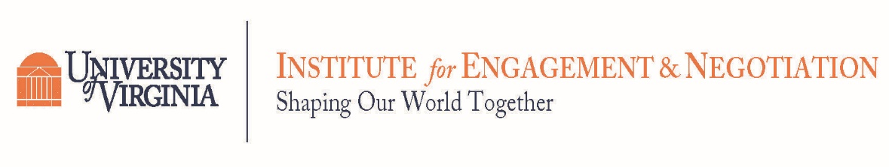

Scientific and Technical Advisory Committee (STAC) Workshop Series:
Improving Modeling and Mitigation Strategies for Poultry Ammonia across the Chesapeake Bay Watershed

Register to receive Zoom Link

9:00 Welcome
Kathy Boomer, Foundation for Food and Agricultural Research, STAC Chair

9:05 Workshop Introduction
Joe Wood, Chesapeake Bay Foundation
Holly Porter, Delmarva Chicken Association

9:20 Presentation Question Task (10 minutes total)
Mike Foreman, University of Virginia
Annabelle Harvey, Chesapeake Research Consortium, STAC Coordinator

JamBoard Test Question: What has been your “go to” restorative activity during the pandemic?
Link 1
Link 2

Session 1: Approaches to Modeling Ammonia Emissions and Transport
Session 1 JamBoard: Link 1, Link 2

9:30 Apportionment of air sources through CMAQ
Jesse Bash, EPA

- What additional questions need to be addressed about this approach?
- What future analyses would be most beneficial?

9:50 A conceptual model of how air sources fit into Chesapeake Bay Modeling, Gary Shenk, USGS

- What are the challenges with the current framework?
- How might the partnership look to modify?

10:10 Local Surveys and improving understanding of implementation
Mark Dubin, University of Maryland
Paul Bredwell, U.S. Poultry and Egg Association

- How can litter surveys improve our understanding? What other ways might we improve our understanding of management efforts?
- How could these inputs inform our modeling efforts?

10:30 Debrief the Modeling Questions
Mike Foreman, University of Virginia

10:35 5-minute Break

Session 2: Approaches to Ammonia Management
Session 2 JamBoard: Link 1, Link 2

10:40 What management strategies influence ammonia transport? What is the relative cost effectiveness? co-benefits?
Hong Li, University of Delaware
Sanjay Shah, North Carolina State University
Eileen Fabian, Penn State University

- What are key challenges related to implementing these BMPs and how might the partnership address these challenges??
- Are there other co-benefits we are not considering?
- What critical research questions remain?

11:40 Debrief the management approaches
Mike Foreman, University of Virginia

11:45 Schedule of future breakout meetings, Future opportunities for participation
Joe Wood, Chesapeake Bay Foundation
Next Steps JamBoard: Link 1, Link 2

- What important questions in this space have we not covered; Do you have suggestions for new groups/ focused discussion?
- Do you have suggested resources we should review?

Future meetings will take a deep dive into these issues, including but not limited to the following.
Please complete this form to attend one or more of these sessions.
- What are the key decisions points related to this issue? Is the partnership supporting these decision points? How might they?
- Historic Cost-Share Investments. What informed current decisions making about investment? Are there opportunities to enhance investment?
- CMAQ apportionment deep dive: How can these new results inform out bay modeling/bay restorations efforts? What questions are there about the approach?
- How much ammonia reaches freshwater portions of the watershed? Any implications?
- Litter Surveys, what do they show, should the bay partnership support this tool, if so, How?
- What is the effectiveness of BMPs at mitigating ammonia? How have these historically been modeled? Cost-effectiveness of ammonia influencing BMPs? co-benefits? carbon, bird health, etc.
12:00 Adjourn

